(Approx. 850 words)

Back to Basics
The System Tray Icons
Jim Cerny, Director, Sarasota PCUG, Florida
September 2012 issue, Sarasota PC Monitor
www.spcug.org
jimcerny123 (at) gmail.com

On all editions of Windows, if you look at the lower right corner of your desktop computer screen -- next to the clock with the time -- you will see some small icons. Have you ever wondered what those icons are and why they are there? Well, this area of the Desktop is called the “System Tray” (or “systray”) and, basically, this area on your taskbar is showing what programs are started when your computer is turned on. Here is a sample shot of my Systray:
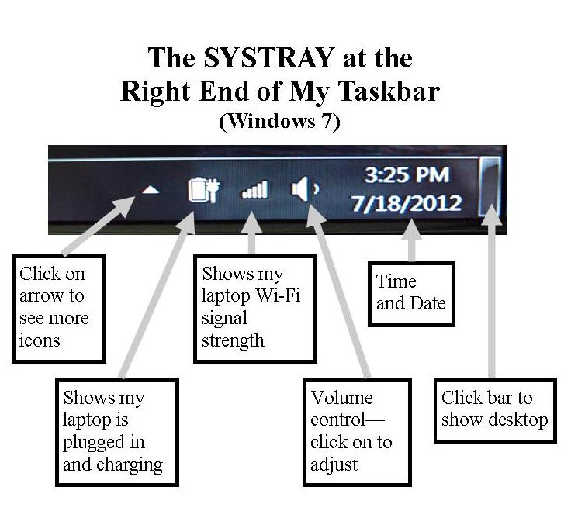
Normally you would not change the icons in this area by deleting them or adding new ones. New icons are added here automatically when you install programs on your computer that are intended to be running “in the background” all the time. But there are a few basic things about these little icons that are very helpful to know.

The Clock – The time and date for your computer should be correct, if not you can change the time and date by left-clicking your mouse on the current time and this will open small window in which you can set your clock and date. Normally you will only have to do this once because it will automatically adjust for daylight savings time. Even when your computer is unplugged, turned off, or if your laptop has no battery power left, the clock is probably still running with its own tiny power supply. The clock is essential to all computer functions because everything you do is recorded with the date and time. If you save a new file, for example, the date and time is recorded with the file.

The Volume Control – This little icon looks like a side view of a speaker. If you “hover” your mouse on that icon it will show you the percent volume level. Click on the icon to open the slide volume control. If you have a desktop computer then you probably also have a set of two external speakers (plugged into a wall outlet) that have their own “on/off” switch and their own volume control. But your external speakers can only project the volume given to them from your computer. So, if you have external speakers, adjust the volume control on your computer to maximum and then use the controls on the external speakers. If you have a laptop (and do not have external speakers connected to it) then you click on this icon to change the volume. Many laptops have a small wheel or buttons on the keyboard to also control the volume. Check your laptop’s manual. If you do have a laptop and want to enjoy beautiful sound for music or movies, a set of external speakers is a great idea.

Your Virus Protection – You should have an active virus protection program running on your computer. If you do you will see an icon in this area which represents this program. Naturally your virus protection program should always be running whenever you start your computer. Click on its icon here to open a window to work with your anti-virus program.

The Laptop Icons – The systray also shows icons about your laptop’s power supply. For example, if my laptop is connected to a wall outlet, I see an icon with a plug symbol. If my laptop is running on battery, I see a battery symbol with a percentage of battery power level remaining.

Wireless Signal Strength Level – Since your laptop connects without wires to the internet in your home (or at McDonald’s or other places) you should have a “bar indicator” icon here that shows the strength of the wireless (Wi-Fi) signal. The more bars the stronger the signal. “Hovering” the mouse on this icon will show you the name of the network you are using. Click on it to see a list of all connections available from which you can select. Naturally you would want to use the connection with the strongest signal, but remember that many wireless networks are secured and require a password to use.

Perhaps there are more icons in this area than can fit into this part of the Taskbar – if so there will be a small triangle “arrowhead” for you to click on to see all the icons. Just hover your mouse over an icon to see a small text box description. If you don’t know what an icon is for, jot down the description and enter that text into Google and find out. You can also Google “systray icons” and get more information.

Remember that the icons you see in your systray will probably be different from the icons that others have on their computers. Perhaps you will not need to know all of them, but if you are a bit curious like me, it could be fun to find out. Just “hover” your mouse on whatever it is and a small label should appear with a short name or description. Then use Google to satisfy your itchy curiosity!

